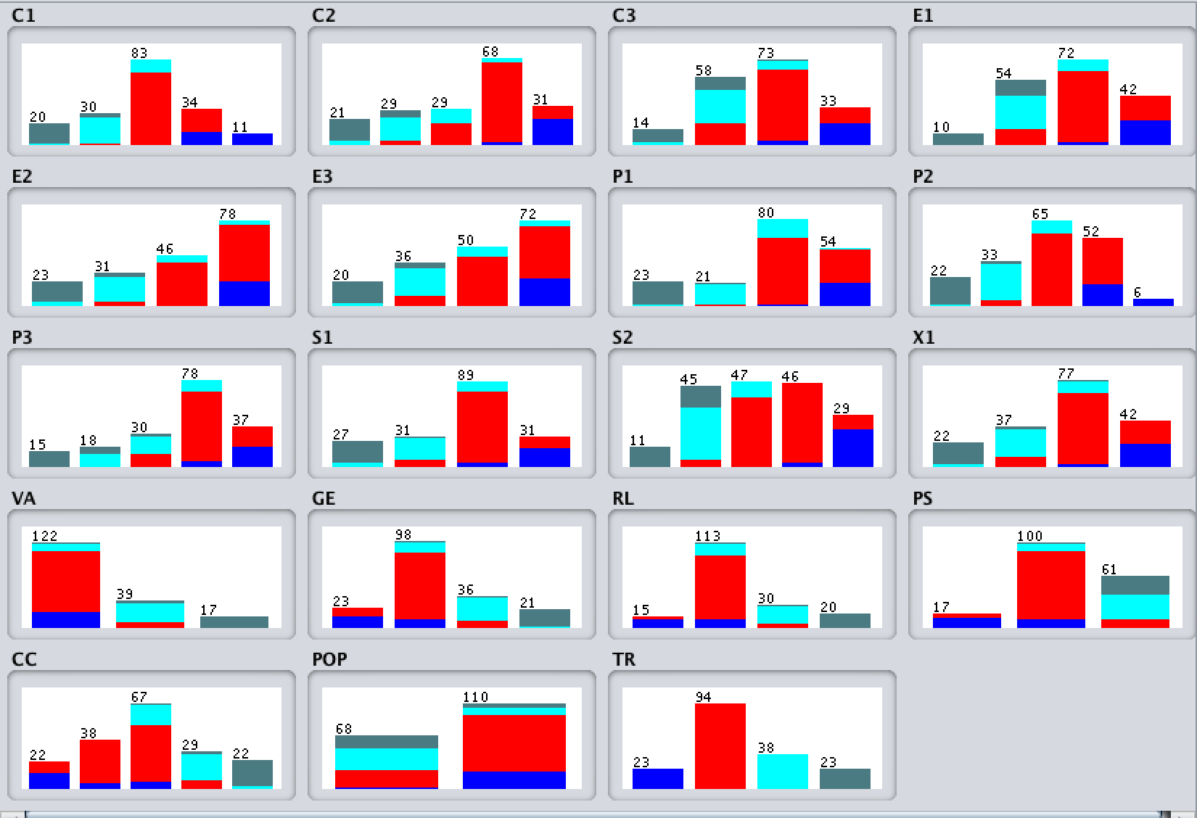

=== Run information ===

Scheme: weka.classifiers.trees.RandomForest -P 100 -I 100 -num-slots 1 -K 0 -M 1.0 -V 0.001 -S 1

Relation: Dataset 2015_x_modified-weka.filters.unsupervised.attribute.Remove-R1-2-weka.filters.supervised.attribute.Discretize-Rfirst-last-precision6

Instances: 178

Attributes: 19

C1

C2

C3

E1

E2

E3

P1

P2

P3

S1

S2

X1

VA

GE

RL

PS

CC

POP

TR

Test mode: 10-fold cross-validation

=== Classifier model (full training set) ===

RandomForest

Bagging with 100 iterations and base learner

weka.classifiers.trees.RandomTree -K 0 -M 1.0 -V 0.001 -S 1 -do-not-check-capabilities

Time taken to build model: 0.05 seconds

=== Stratified cross-validation ===

=== Summary ===

Correctly Classified Instances 168 94.382 %

Incorrectly Classified Instances 10 5.618 %

Kappa statistic 0.9146

Mean absolute error 0.0704

Root mean squared error 0.1567

Relative absolute error 21.192 %

Root relative squared error 38.5272 %

Total Number of Instances 178

=== Detailed Accuracy By Class ===

TP Rate FP Rate Precision Recall F-Measure MCC ROC Area PRC Area Class

0.960 0.007 0.960 0.960 0.960 0.953 1.000 0.998 Alert

0.966 0.056 0.945 0.966 0.956 0.910 0.991 0.991 Warning

0.900 0.029 0.900 0.900 0.900 0.871 0.991 0.974 Stable

0.917 0.000 1.000 0.917 0.957 0.951 1.000 1.000 Sustainable

Weighted Avg. 0.944 0.036 0.944 0.944 0.944 0.913 0.994 0.989

=== Confusion Matrix ===

a b c d <-- classified as

24 1 0 0 | a = Alert

1 86 2 0 | b = Warning

0 4 36 0 | c = Stable

0 0 2 22 | d = Sustainable

=== Run information ===

Scheme: weka.classifiers.trees.RandomTree -K 0 -M 1.0 -V 0.001 -S 1

Relation: Dataset 2015_x_modified-weka.filters.unsupervised.attribute.Remove-R1-2-weka.filters.supervised.attribute.Discretize-Rfirst-last-precision6

Instances: 178

Attributes: 19

C1

C2

C3

E1

E2

E3

P1

P2

P3

S1

S2

X1

VA

GE

RL

PS

CC

POP

TR

Test mode: 10-fold cross-validation

=== Classifier model (full training set) ===

RandomTree

==========

P1 = '(-inf-2.75]' : Sustainable (22/0)

P1 = '(2.75-4.75]'

| P2 = '(-inf-2.15]' : Sustainable (1/0)

| P2 = '(2.15-4.6]'

| | C3 = '(-inf-3.65]' : Sustainable (1/0)

| | C3 = '(3.65-5.65]' : Stable (11/0)

| | C3 = '(5.65-7.75]' : Stable (6/0)

| | C3 = '(7.75-inf)' : Alert (0/0)

| P2 = '(4.6-7.45]'

| | E1 = '(-inf-2.55]' : Alert (0/0)

| | E1 = '(2.55-5.95]' : Stable (2/0)

| | E1 = '(5.95-6.85]' : Stable (1/0)

| | E1 = '(6.85-inf)' : Warning (1/0)

| P2 = '(7.45-inf)' : Alert (0/0)

P1 = '(4.75-6.95]'

| S1 = '(-inf-3.05]' : Stable (1/0)

| S1 = '(3.05-5.25]'

| | E3 = '(-inf-2.9]' : Stable (2/0)

| | E3 = '(2.9-4.65]'

| | | C2 = '(-inf-2.75]' : Alert (0/0)

| | | C2 = '(2.75-4.7]' : Stable (1/0)

| | | C2 = '(4.7-7.85]' : Stable (3/0)

| | | C2 = '(7.85-8.85]' : Warning (1/0)

| | | C2 = '(8.85-inf)' : Alert (0/0)

| | E3 = '(4.65-6.35]' : Stable (2/0)

| | E3 = '(6.35-inf)' : Stable (5/0)

| S1 = '(5.25-8.05]'

| | E3 = '(-inf-2.9]' : Alert (0/0)

| | E3 = '(2.9-4.65]'

| | | X1 = '(-inf-2.05]' : Alert (0/0)

| | | X1 = '(2.05-4.65]' : Stable (2/0)

| | | X1 = '(4.65-7.85]' : Warning (3/0)

| | | X1 = '(7.85-9.35]' : Alert (0/0)

| | | X1 = '(9.35-inf)' : Alert (0/0)

| | E3 = '(4.65-6.35]' : Warning (5/0)

| | E3 = '(6.35-inf)'

| | | P3 = '(-inf-1.85]' : Alert (0/0)

| | | P3 = '(1.85-4.85]'

| | | | E1 = '(-inf-2.55]' : Alert (0/0)

| | | | E1 = '(2.55-5.95]' : Stable (1/0)

| | | | E1 = '(5.95-6.85]' : Warning (3/0)

| | | | E1 = '(6.85-inf)' : Warning (3/0)

| | | P3 = '(4.85-7.85]' : Warning (13/0)

| | | P3 = '(7.85-inf)' : Alert (0/0)

| S1 = '(8.05-inf)' : Warning (5/0)

P1 = '(6.95-8.95]'

| S1 = '(-inf-3.05]' : Alert (0/0)

| S1 = '(3.05-5.25]'

| | C2 = '(-inf-2.75]' : Alert (0/0)

| | C2 = '(2.75-4.7]' : Alert (0/0)

| | C2 = '(4.7-7.85]'

| | | E1 = '(-inf-2.55]' : Alert (0/0)

| | | E1 = '(2.55-5.95]' : Stable (3/0)

| | | E1 = '(5.95-6.85]' : Warning (2/0)

| | | E1 = '(6.85-inf)' : Alert (0/0)

| | C2 = '(7.85-8.85]' : Warning (6/0)

| | C2 = '(8.85-inf)' : Warning (1/0)

| S1 = '(5.25-8.05]' : Warning (26/0)

| S1 = '(8.05-inf)'

| | C3 = '(-inf-3.65]' : Alert (0/0)

| | C3 = '(3.65-5.65]' : Warning (4/0)

| | C3 = '(5.65-7.75]'

| | | E3 = '(-inf-2.9]' : Alert (0/0)

| | | E3 = '(2.9-4.65]' : Alert (0/0)

| | | E3 = '(4.65-6.35]' : Warning (4/0)

| | | E3 = '(6.35-inf)'

| | | | PS = '(-inf--1.803675]' : Alert (0/0)

| | | | PS = '(-1.803675-0.093425]'

| | | | | X1 = '(-inf-2.05]' : Alert (0/0)

| | | | | X1 = '(2.05-4.65]' : Alert (0/0)

| | | | | X1 = '(4.65-7.85]' : Warning (1/0)

| | | | | X1 = '(7.85-9.35]'

| | | | | | S2 = '(-inf-3.15]' : Alert (0/0)

| | | | | | S2 = '(3.15-5.35]' : Alert (0/0)

| | | | | | S2 = '(5.35-7.35]' : Warning (1/0)

| | | | | | S2 = '(7.35-8.85]' : Alert (1/0)

| | | | | | S2 = '(8.85-inf)' : Alert (0/0)

| | | | | X1 = '(9.35-inf)' : Alert (1/0)

| | | | PS = '(0.093425-0.879915]' : Warning (1/0)

| | | | PS = '(0.879915-inf)' : Alert (0/0)

| | C3 = '(7.75-inf)'

| | | S2 = '(-inf-3.15]' : Alert (0/0)

| | | S2 = '(3.15-5.35]' : Alert (0/0)

| | | S2 = '(5.35-7.35]' : Warning (1/0)

| | | S2 = '(7.35-8.85]'

| | | | P3 = '(-inf-1.85]' : Alert (0/0)

| | | | P3 = '(1.85-4.85]' : Alert (0/0)

| | | | P3 = '(4.85-7.85]'

| | | | | C2 = '(-inf-2.75]' : Alert (0/0)

| | | | | C2 = '(2.75-4.7]' : Alert (0/0)

| | | | | C2 = '(4.7-7.85]' : Alert (0/0)

| | | | | C2 = '(7.85-8.85]' : Warning (1/0)

| | | | | C2 = '(8.85-inf)' : Alert (1/0)

| | | | P3 = '(7.85-inf)' : Alert (1/0)

| | | S2 = '(8.85-inf)' : Alert (4/0)

P1 = '(8.95-inf)'

| E1 = '(-inf-2.55]' : Alert (0/0)

| E1 = '(2.55-5.95]' : Warning (3/0)

| E1 = '(5.95-6.85]' : Warning (2/0)

| E1 = '(6.85-inf)'

| | C2 = '(-inf-2.75]' : Alert (0/0)

| | C2 = '(2.75-4.7]' : Alert (0/0)

| | C2 = '(4.7-7.85]' : Alert (0/0)

| | C2 = '(7.85-8.85]'

| | | S2 = '(-inf-3.15]' : Alert (0/0)

| | | S2 = '(3.15-5.35]' : Warning (2/0)

| | | S2 = '(5.35-7.35]' : Alert (0/0)

| | | S2 = '(7.35-8.85]' : Alert (1/0)

| | | S2 = '(8.85-inf)' : Alert (0/0)

| | C2 = '(8.85-inf)' : Alert (16/0)

Size of the tree : 111

Time taken to build model: 0 seconds

=== Stratified cross-validation ===

=== Summary ===

Correctly Classified Instances 155 87.0787 %

Incorrectly Classified Instances 23 12.9213 %

Kappa statistic 0.8041

Mean absolute error 0.0654

Root mean squared error 0.2495

Relative absolute error 19.7137 %

Root relative squared error 61.3337 %

Total Number of Instances 178

=== Detailed Accuracy By Class ===

TP Rate FP Rate Precision Recall F-Measure MCC ROC Area PRC Area Class

0.920 0.020 0.885 0.920 0.902 0.886 0.950 0.821 Alert

0.888 0.124 0.878 0.888 0.883 0.764 0.891 0.848 Warning

0.775 0.065 0.775 0.775 0.775 0.710 0.868 0.672 Stable

0.917 0.000 1.000 0.917 0.957 0.951 0.958 0.928 Sustainable

Weighted Avg. 0.871 0.079 0.872 0.871 0.871 0.794 0.903 0.816

=== Confusion Matrix ===

a b c d <-- classified as

23 2 0 0 | a = Alert

3 79 7 0 | b = Warning

0 9 31 0 | c = Stable

0 0 2 22 | d = Sustainable

=== Run information ===

Scheme: weka.classifiers.trees.J48 -C 0.25 -M 2

Relation: Dataset 2015_x_modified-weka.filters.unsupervised.attribute.Remove-R1-2-weka.filters.supervised.attribute.Discretize-Rfirst-last-precision6

Instances: 178

Attributes: 19

C1

C2

C3

E1

E2

E3

P1

P2

P3

S1

S2

X1

VA

GE

RL

PS

CC

POP

TR

Test mode: 10-fold cross-validation

=== Classifier model (full training set) ===

J48 pruned tree

------------------

C1 = '(-inf-2.25]': Sustainable (19.0)

C1 = '(2.25-4.75]'

| P1 = '(-inf-2.75]': Sustainable (5.0)

| P1 = '(2.75-4.75]': Stable (19.0)

| P1 = '(4.75-6.95]': Stable (10.0/2.0)

| P1 = '(6.95-8.95]': Stable (1.0)

| P1 = '(8.95-inf)': Stable (0.0)

C1 = '(4.75-7.45]'

| VA = '(-inf-0.430185]'

| | GE = '(-inf--1.09803]': Warning (6.0/1.0)

| | GE = '(-1.09803-0.415515]': Warning (60.0/1.0)

| | GE = '(0.415515-1.202875]': Stable (4.0)

| | GE = '(1.202875-inf)': Warning (0.0)

| VA = '(0.430185-1.204645]'

| | E1 = '(-inf-2.55]': Stable (0.0)

| | E1 = '(2.55-5.95]': Stable (6.0)

| | E1 = '(5.95-6.85]': Warning (2.0)

| | E1 = '(6.85-inf)': Warning (2.0/1.0)

| VA = '(1.204645-inf)': Warning (0.0)

C1 = '(7.45-9.2]'

| S1 = '(-inf-3.05]': Warning (0.0)

| S1 = '(3.05-5.25]': Warning (3.0)

| S1 = '(5.25-8.05]': Warning (13.0)

| S1 = '(8.05-inf)'

| | E1 = '(-inf-2.55]': Alert (0.0)

| | E1 = '(2.55-5.95]': Alert (0.0)

| | E1 = '(5.95-6.85]': Warning (2.0)

| | E1 = '(6.85-inf)': Alert (14.0/2.0)

C1 = '(9.2-inf)': Alert (12.0)

Number of Leaves : 23

Size of the tree : 30

Time taken to build model: 0 seconds

=== Stratified cross-validation ===

=== Summary ===

Correctly Classified Instances 154 86.5169 %

Incorrectly Classified Instances 24 13.4831 %

Kappa statistic 0.8011

Mean absolute error 0.0785

Root mean squared error 0.2401

Relative absolute error 23.6488 %

Root relative squared error 59.0075 %

Total Number of Instances 178

=== Detailed Accuracy By Class ===

TP Rate FP Rate Precision Recall F-Measure MCC ROC Area PRC Area Class

0.920 0.059 0.719 0.920 0.807 0.779 0.961 0.857 Alert

0.831 0.067 0.925 0.831 0.876 0.768 0.926 0.905 Warning

0.900 0.058 0.818 0.900 0.857 0.815 0.939 0.831 Stable

0.875 0.006 0.955 0.875 0.913 0.901 0.952 0.880 Sustainable

Weighted Avg. 0.865 0.056 0.876 0.865 0.867 0.798 0.937 0.878

=== Confusion Matrix ===

a b c d <-- classified as

23 2 0 0 | a = Alert

9 74 6 0 | b = Warning

0 3 36 1 | c = Stable

0 1 2 21 | d = Sustainable